Phase 1 — Define Problem Statements
Implement Client Script & UI Policy (Incident)
01 October 2026 | Phase 1 |SWTID-2026-4755
Field | Project value
Date | 01 October 2026
Team ID | SWTID-2026-4755
Project Name | Implement Client Script & UI Policy (Incident)
Phase 1 focus | Translate the Incident implementation challenge into user-centered problem statements
1. Customer and operational context
The primary customer is the service desk operation that depends on accurate Incident records. The direct user is the service desk agent, while Incident managers, assignment-group leads, SLA owners, and administrators rely on the record after it is submitted.
Stakeholder | Current concern | Desired outcome
Service desk agent | Must remember several conditions while responding quickly. | Clear, immediate guidance that appears only when an Incident is high impact.
Incident manager | May receive a high-impact record with weak routing or ownership. | Complete Assignment group and Assigned To data.
SLA/reporting owner | Inconsistent urgency and incomplete records weaken reporting. | Consistent values and auditable changes.
ServiceNow administrator | Needs maintainable configuration that can be verified. | Named, scoped, reversible UI controls and scripts.
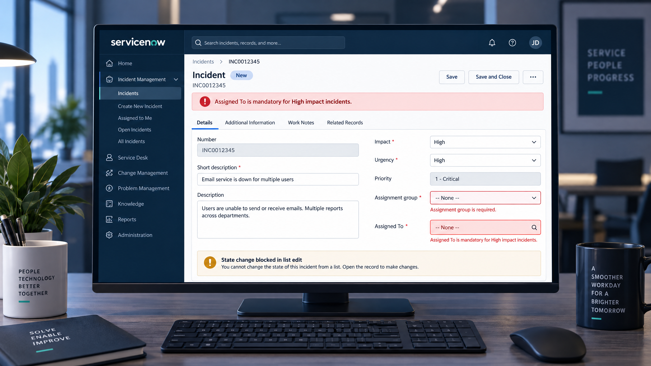
Generated project visual: the user problem appears as an actionable validation state in the Incident form.
2. Observed problem areas from the project PDF
• Manual entry can produce incomplete or incorrect Incident data.
• High-impact records need stronger routing and ownership controls.
• Urgency can be inconsistent if Impact and Urgency are entered independently.
• Saving without Assigned To can create an ownerless record.
• List editing can change State without the full form context.
• Controls that do not reverse can create friction after Impact is lowered.
3. Problem statement options
ID | Problem statement | Evidence / implication
PS-01 | Service desk agents need a reliable way to complete high-impact Incident routing because manual checks can leave Assignment group missing. | The UI Policy makes Assignment group mandatory when Impact is High.
PS-02 | Incident managers need urgency to align with high impact because separate manual entry can create inconsistent triage signals. | The onChange script sets Urgency to High and the UI Policy controls the field.
PS-03 | Service desk operations need to prevent ownerless high-impact Incidents because a record without Assigned To can delay response. | The onSubmit script blocks save and shows a field-level error.
PS-04 | Administrators need to protect workflow State from context-free list edits because direct edits can bypass form validation. | The onCellEdit script rejects State changes and directs the user to the form.
PS-05 | Agents need conditional rather than permanent restrictions because a Medium/Low Impact Incident should return to normal behavior. | Reverse if false restores the UI Policy behavior.
4. Selected customer problem statement
Service desk agents need a fast and understandable way to create trustworthy high-impact Incidents because manual checks alone can leave routing, urgency, ownership, and State data incomplete or inconsistent. The platform should apply stronger controls only when Impact is High, explain blocked actions, automate repeatable decisions, and allow normal behavior to return when the condition is no longer true.
5. “How might we” framing
How might we make high-impact Incident entry safe by default without slowing routine work or forcing agents to remember every validation rule?
6. Scope boundaries
• In scope: Incident form/list behavior, UI Policy, UI Policy Actions, onChange, onSubmit, onCellEdit, and manual verification.
• Out of scope for Phase 1: server-side integration enforcement, predictive prioritization, analytics dashboards, and production rollout governance.
• Security boundary: client-side controls improve usability and data quality; ServiceNow roles, ACLs, and server-side policies remain authoritative.
7. Problem-to-solution traceability
The selected problem statement maps directly to the supplied implementation tasks: Task 1 defines High Impact Control, Task 2 controls Urgency, Tasks 3–5 implement the three Client Script types, and Task 6 verifies mandatory enforcement, successful save, reversal, list-edit blocking, and form-based update.

